Mun Yee

Ideal Location for Chinese Restaurant in Toronto

Capstone Report

IBM Data Science

## **Introduction**

**Background**

Toronto is the provincial capital of Ontario and the most populous city in Canada, with a population of 2,731,571 in 2016. Toronto encompasses a geographical area formerly administered by many separate municipalities. These municipalities have each developed a distinct history and identity over the years, and their names remain in common use among Torontonians. Throughout the city there exist hundreds of small neighbourhoods and some larger neighbourhoods covering a few square kilometres. The three most commonly reported ethnic origins overall were Chinese (332,830 or 12.5%), English (331,890 or 12.3%) and Canadian (323,175 or 12.0%).

Opening a new restaurant is always an adventure and can be an extremely stressful matter especially for a city like Toronto which may already have clusters of various restaurants already exist in the city. All over the city, chefs infuse their cooking with a globe of influences while creative restauranteurs experiment with new concepts and gustatory innovations.

With this capstone project, the idea is to give some guidance to someone who interested to open a new Chinese restaurant but he/she is new to the market and city. This guide will help them in choosing the right location by giving them a brief overview of the neighbourhoods in Toronto, population, the household income, spending power and the competitors already present in the same region.

**Data**

In order to solve the explained business problem, geographical and population data is needed for analysis. Various information about the city is readily available from the Toronto webpage. In this project, the population, income and spending ability data were obtained from Toronto site. Location data for Toronto neighbourhoods were collected using Foursquare API and existing restaurants in the region were further obtained and analysed.

**Methodology**

In the beginning of the project, Toronto’s neighbourhoods, borough, latitude and longitude for each neighbourhood were cleaned and combined. Using available income and population data, the median spending power of each area is calculated. The total number and type of restaurants available in the region is also collected.

The next step is to visualise the location of various regions within Toronto using Foursquare API and obtain a general overview of the location. Based on the map (figure 1), the postcodes are mainly clustering around Toronto downtime area. The population in downtime area are considerably higher compare to other regions and tend to spread out as move away from Toronto downtown.

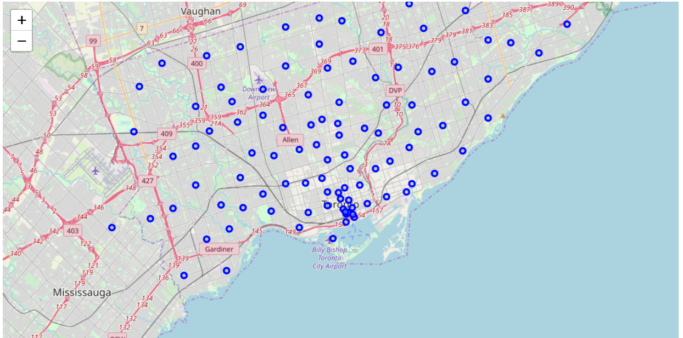

Figure 1: Overview of Toronto postcode locations

The top 200 venues within 2000 meters of each postcode were further obtained and ranked. The total number of restaurant and number of Chinese restaurants is also calculated as shown in Table 1.

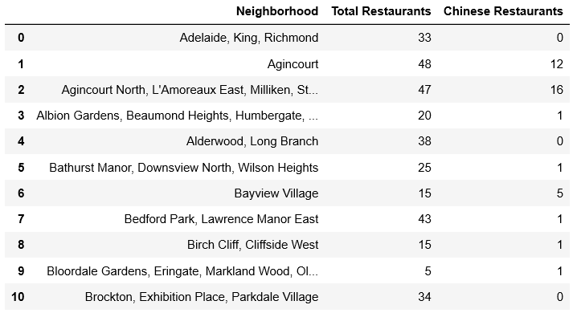

Table 1: Total no. of restaurants and no. of Chinese restaurant in each neighbourhood

The datasets of neighbourhood, latitude, longitude, population and income distribution in Canadian dollar are then combined according sorted according to each neighbourhood (figure 3).

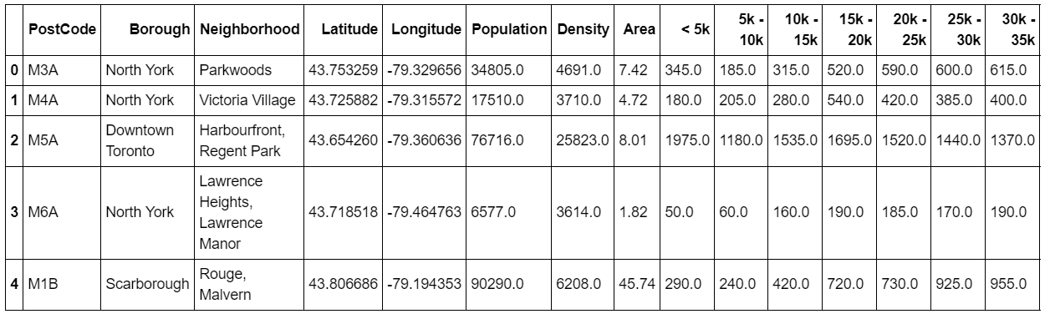

Tablet 2(i): Income data per household for each neighbourhood

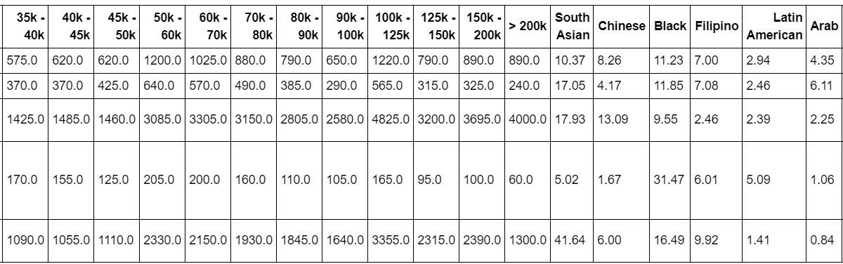

Tablet 2 (ii): Income data per household for each neighbourhood(cont.)

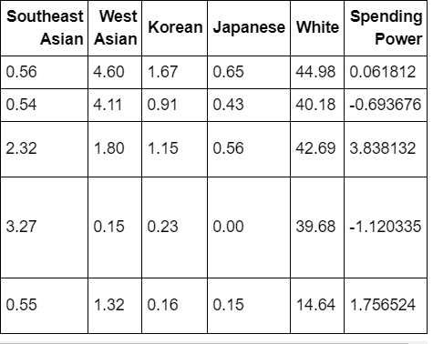

Tablet 2 (iii): Income data per household for each neighbourhood(cont.)

Second part of the project is to perform clustering for different region of the neighbourhoods. K-Means clustering algorithm dividing to 5 clusters were performed for the population, area, Chinese population, spending power, total number of restaurants and number of Chinese restaurant (Figure 2).

**Result**

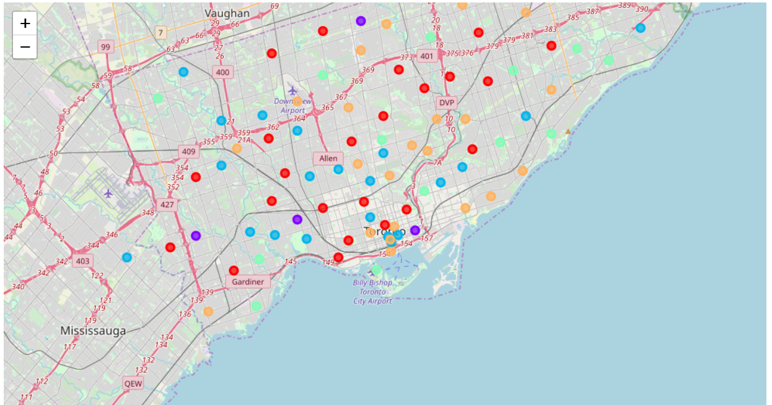

Figure 2: Clustering regions based on population, area, spending power, total no. of restaurant and no. of Chinese restaurant (Red= Cluster 0, Purple = Cluster 1, Blue = Cluster 2, Turquoise = Cluster 3, Orange= Cluster 4)

|  |  |
| --- | --- |
| Cluster Label | Characteristics |
| 0 | Low population, low spending power (-0.4 to 0.6), various % of restaurant, area and Chinese |
| 1 | Generally high population, high spending power (1.7 to 3.8), various % of area and Chinese. Scarborough has the highest no. of Chinese restaurant in this cluster |
| 2 | Low population and extremely low spending power (negative) |
| 3 | Average size of population and average spending power (0.2- 1.7) |
| 4 | Low population and low spending power (negative to 0.2) |

Table 3: Characteristic of each cluster

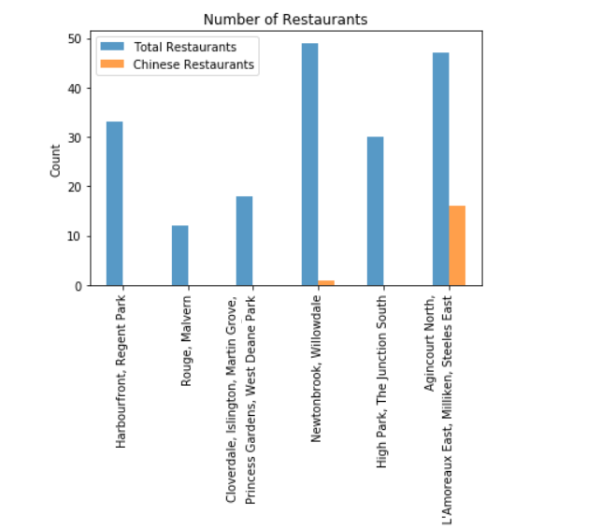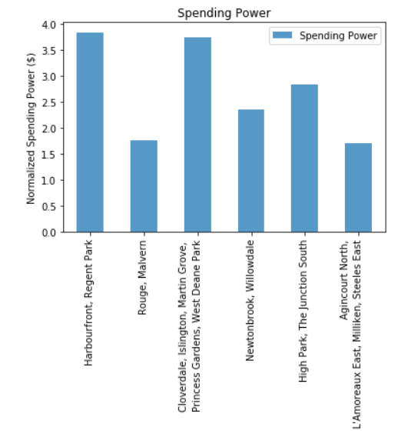

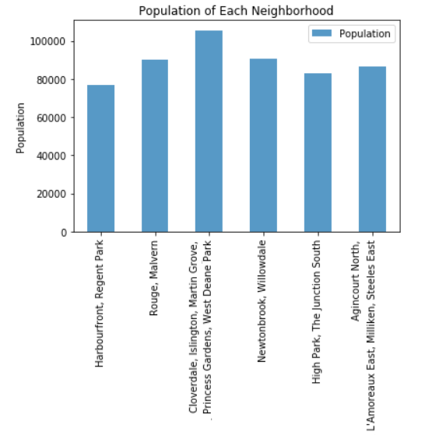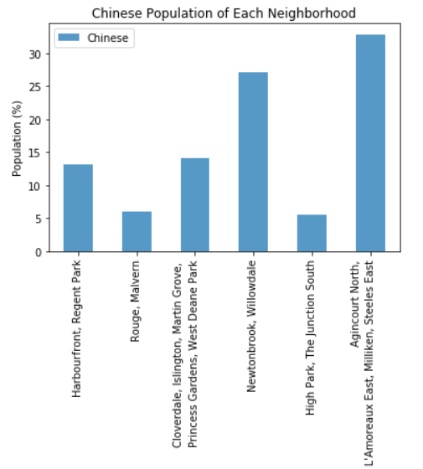

Figure 3: Plots that show characteristic of neighbourhoods belong to cluster label=1

**Discussion**

Based on the clustering algorithm results, cluster label= 1 has the largest population and highest normalised spending power compare to other regions. Cluster region 1 found to be the most appropriate region to open a new Chinese restaurant.

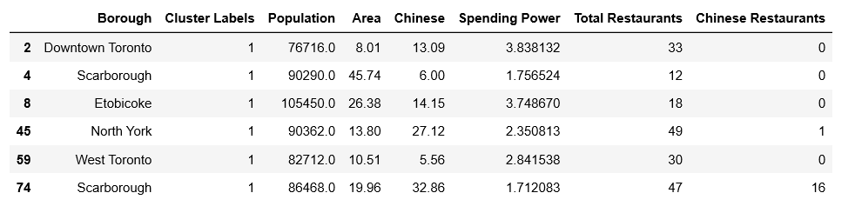

Table 4: Details of neighbourhood in Cluster=1

There are total of six boroughs that are clustered under Cluster 1. Out of the six boroughs, Etobicoke found to have the highest population in all regions. The spending power of 3.75 for people in this borough are among few of the highest in Toronto. On top of that, the number of restaurants in this area is 18 and there is no Chinese restaurant currently present in this region. The neighbourhoods in this borough are Cloverdale, Islington, Martin Grove, Princess Gardens and West Deane Park. The % of Chinese Canadian in this region is about 14.15% which is higher than the Scarborough (4) who have lower % of Chinese but fewer restaurant compare to Etobicoke. Based on the results obtained, Etobicoke (Cloverdale, Islington, Martin Grove, Princess Gardens and West Deane Park) appear to be the most approach region to open a Chinese restaurant due to its high spending power and high population. This area stands a higher chance of success due to its relative low number of restaurant and no Chinese restaurant at present would be an advantage.

**Conclusion**

Opening a new restaurant in one of the big cities in Canada is not an easy task and can lead of monetary loss if not planned well. Extensive research and analysis of the area, population as well as the spending pattern in the area could help in choosing the right location and increase chances of success. Through this project, I manage to do thorough research analysis to help client with the location choice for the new restaurant. Etobicoke region (Cloverdale, Islington, Martin Grove, Princess Gardens and West Deane Park) would be the recommended region for the new restaurant.